**Frontend Development with React.js**

### Project Documentation format

### 1.INTREODUSTION

**Project Title**: Cookbook: your vit kitchen Assistant.

* + **Team Members**: Boopathi. P (Coding developer)
  + **Gokil Priyan**. B (document developer)
  + **Muralidharan**. M (video editing)
  + **MahasHree Guhan**. M (uploder)

1. **Project Overview:**
   * **Purpose**: The primary goa of Cookbook is provide user Friendly.
   * **Features: A cookbook or cookery book [1] is a culinary reference work that contains a collection of recipes.**
2. **Architecture:**
   * **Component Structure**: The components folder stores all the files.
   * **State Management**: The most commonly used units in cooking are the litre and the millilitre.
   * **Routing**: Cookbook kitchen routing for two lines typically refers to setting distinct preparation areas.
3. **Setup Instructions:**
   * **Prerequisites**: A basic cookbook kitchen requires essential appliances like a stove and refrigerator.
   * **Installation**: you have cookbook kitchen requires essential appliances like your local machine.
4. **Folder Structure:**
   * **Client**: The chef-client cookbook provides several resources for setting up chef infra client to run on a schedule.
   * **Utilities**: “Essential kitchen utilities include sharp knives, cutting boards, and measuring cups.
5. **Running the Application:**
   * Provide commands to start the frontend server locally.
     + **Frontend**:” A visually appealing cookbook frontend features stunning food photography and clear recipe layouts.
6. **Component Documentation:**
   * **Key Components**: “key components of a cookbook kitchen include essential cookware like pots, pans, and utensils”.
   * **Reusable Components**: “Reusable components in a cookbook kitchen include silicone baking mats stainless steel”.
7. **State Management:**
   * **Global State**: Global ingredients like salt, sugar, and olive oil are staples in kitchens worldwide.
   * **Local State**: Local ingredients like fresh herbs, vegetables, and fruits are essential for creating authentic flavors in a cookbook kitchen.
8. **User Interface:**
   * Provide screenshots or GIFs showcasing different UI features, such as pages, forms, or interactions.
9. **Styling kitchen styling for a cookbook involves creating visually appealing setting with props, lighting, and composition to showcase dishes:**

* **CSS Frameworks/Libraries**: Describe any CSS frameworks, libraries, or pre-processors (e.g., Sass, Styled-Components) used.
* **Theming**: Explain if theming or custom design systems are implemented.

1. **Testing:**

* **Testing Strategy**: Describe the testing approach for components, including unit, integration, and end-to-end testing (e.g., using Jest, React Testing Library).
* **Code Coverage**: Explain any tools or techniques used for ensuring adequate test coverage.

1. **Screenshots or Demo:**

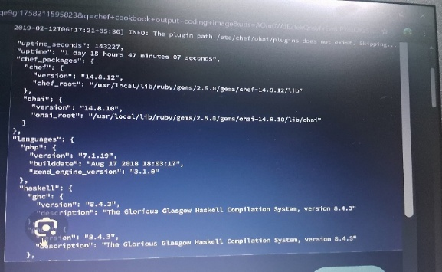

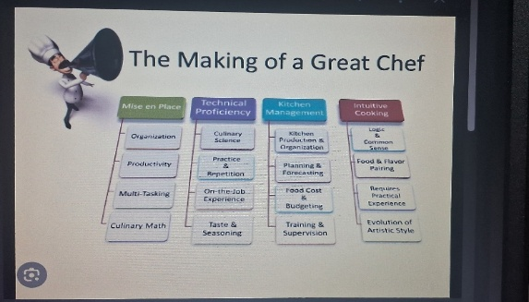

1. **Known Issues:**

* Document any known bugs or issues that users or developers should be aware of.

1. **Future Enhancements:**

* Outline potential future features or improvements, such as new components, animations, or enhanced.